English edition

The 5th Toda City Lifelong Learning Promotion Plan
Summary Version

The year of Plan：２０２１～２０２５
Toda City Board of Education Secretariat Lifelong Learning Division

【The point of the plan】

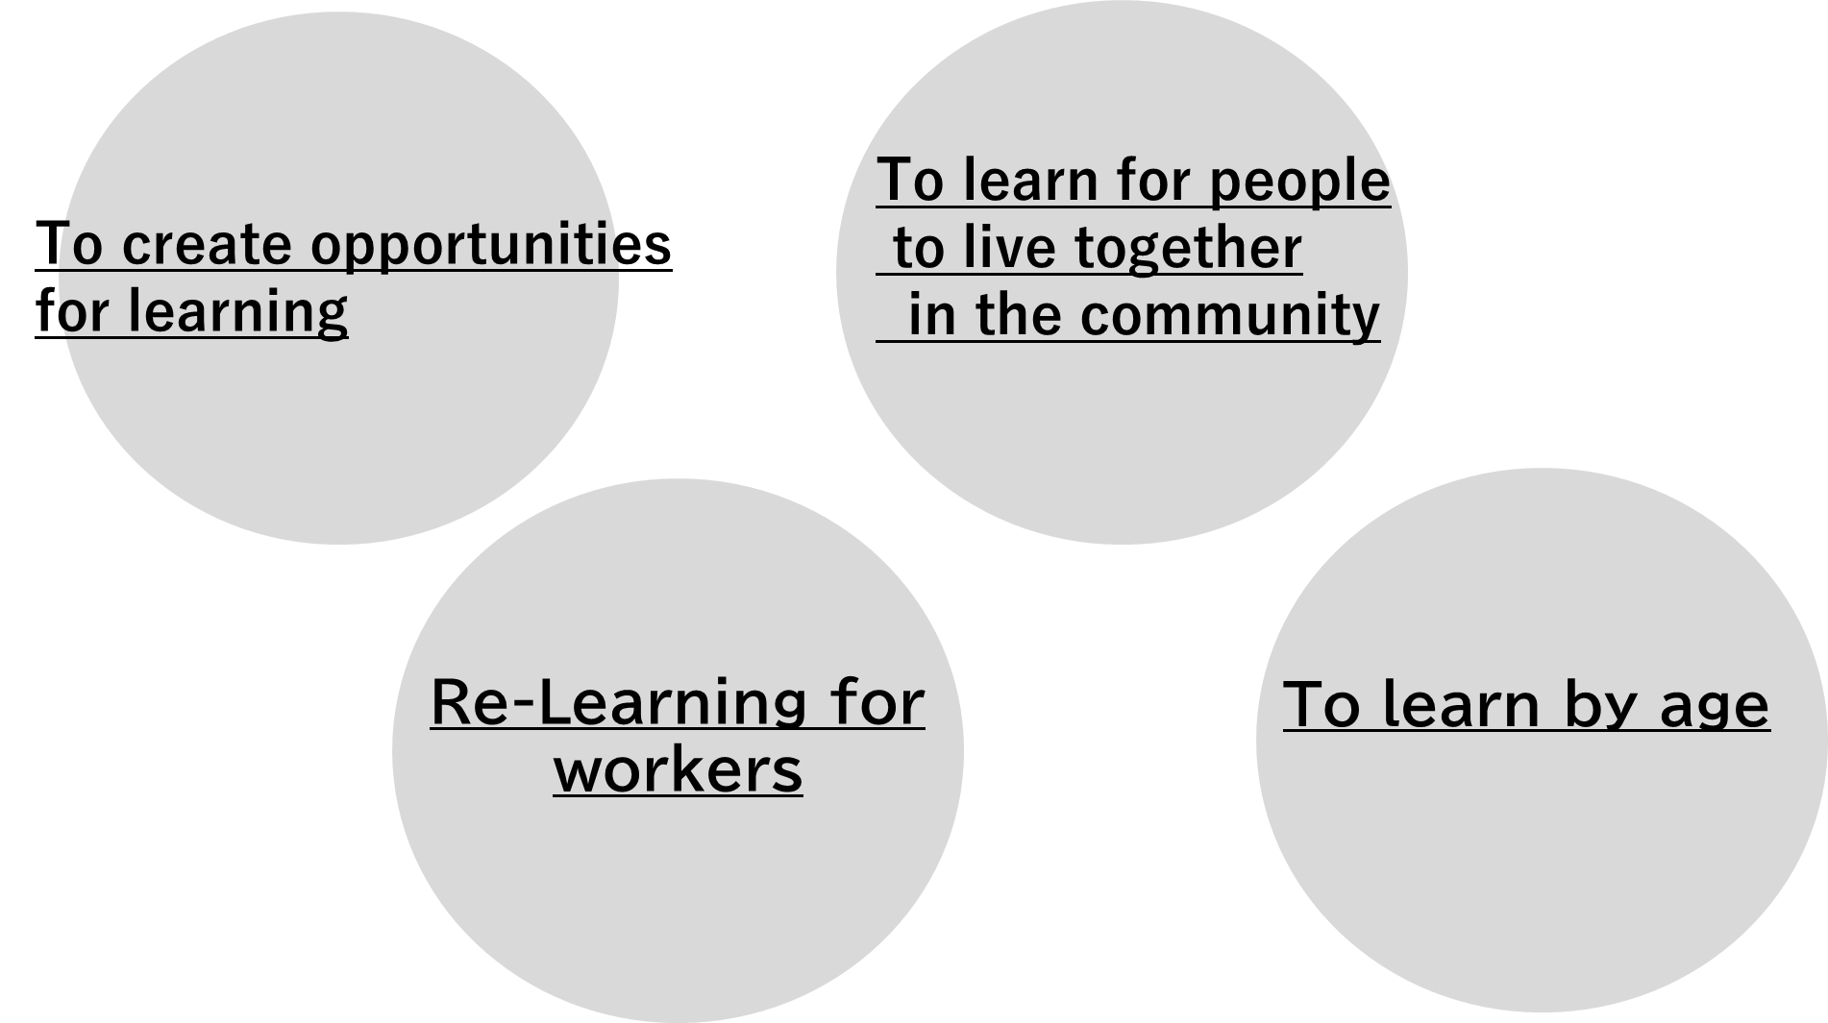

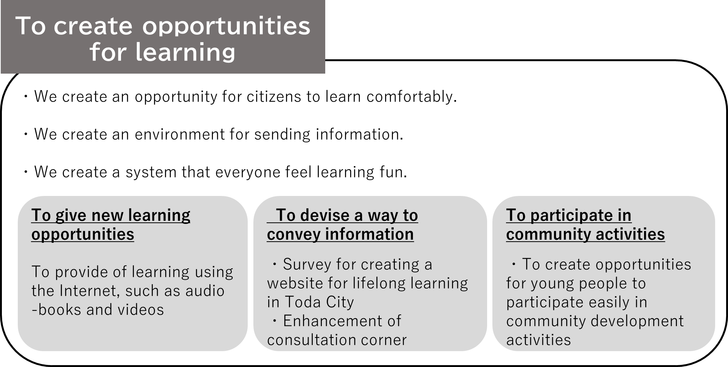
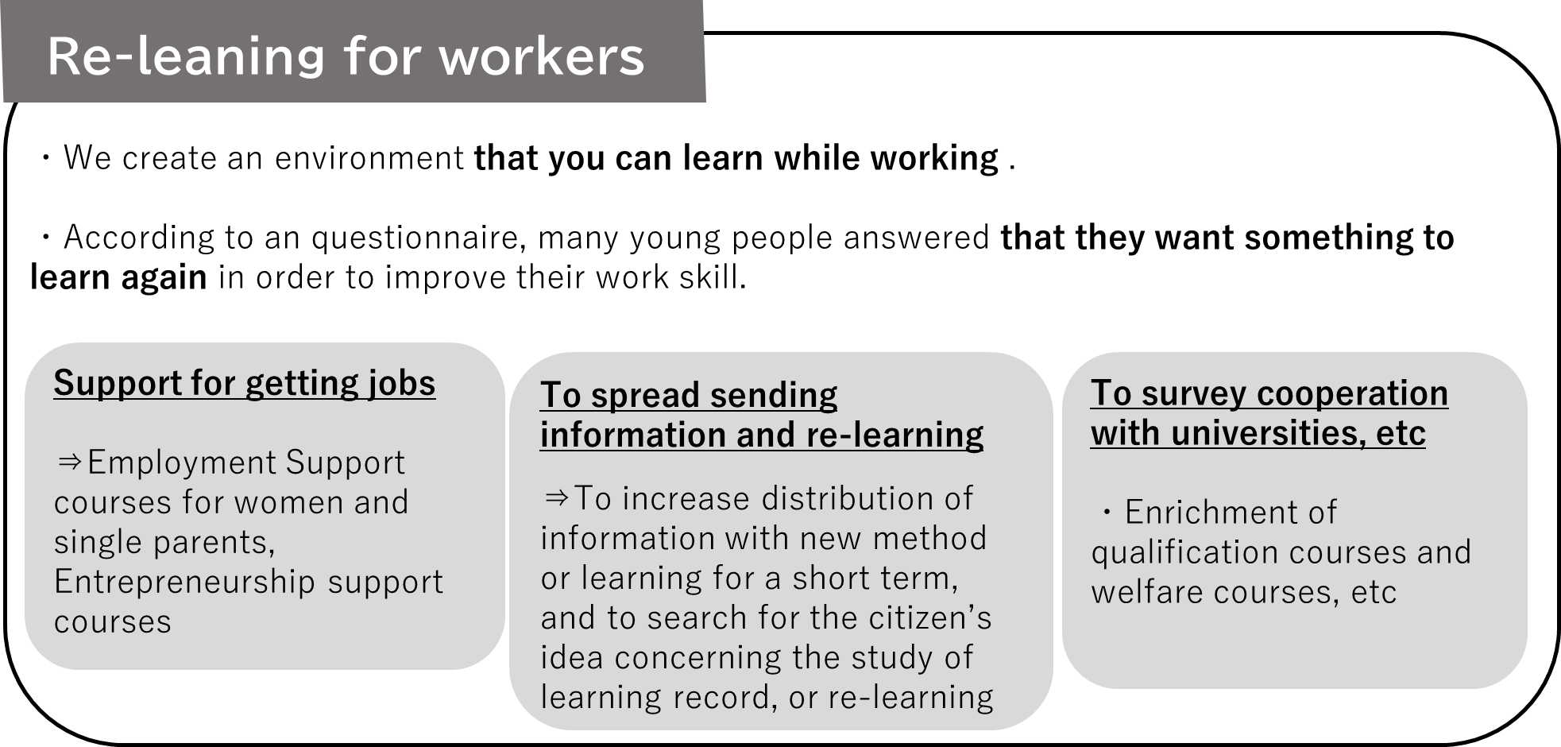

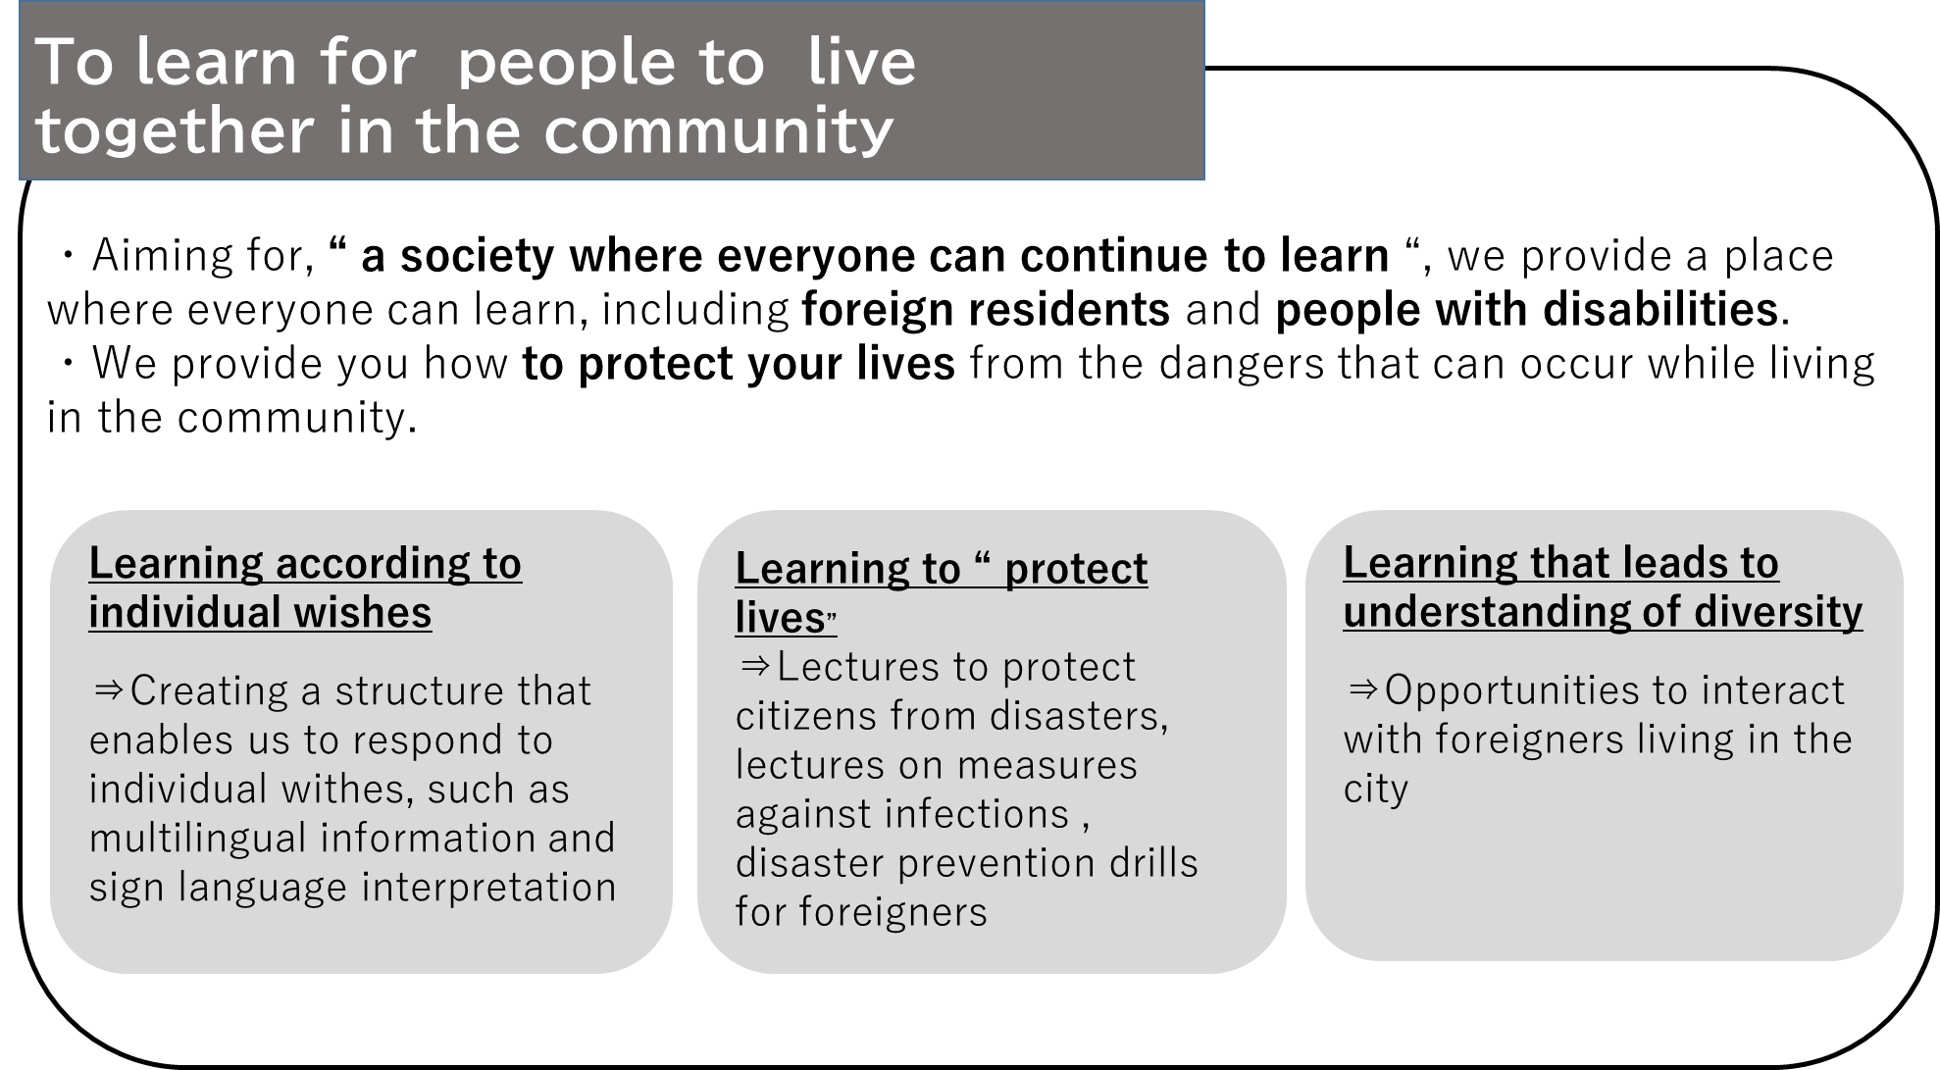

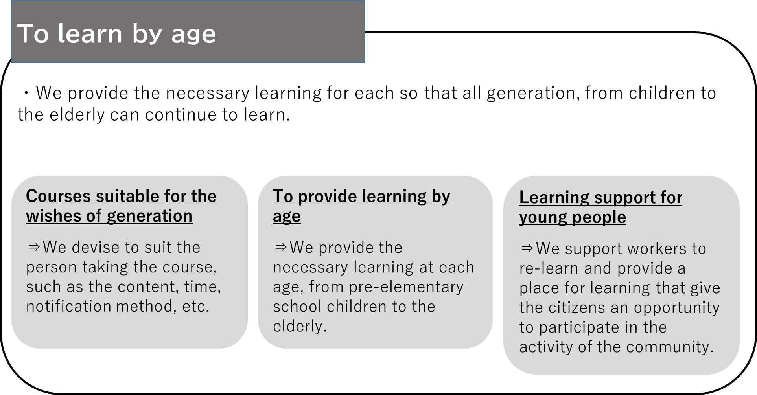

【Planning policy】
Basic policy1
To meet a new-yourself ～To create opportunities for learning ～

measure | method
To give opportunity for learning activities | Use of ICT
 | We increase courses that give you the opportunities to participate in lifelong learning.
We strengthen the information provision, & consultation system. | We send you information about lifelong learning in a variety of possible ways.
 | We strengthen consultation system.

Basic policy2 We live affluently in the age of 100 years.
～To provide learning that meets the age and various wishes of citizens.～

measure | method
We increase learning by age | We increase learning for the children before entering elementary school.
 | We increase learning for elementary school students.
 | We increase learning for Junior High School and High School students.
 | We increase learning for adults.
 | We increase learning for the elderly.
 | We promote re-learning for workers.
To support learning  in the society that we live together | We raise awareness of human rights.
 | We support the learning for people with disabilities.
 | We support everyone to learn.
We increase learning adapted to contemporary・  social challenges  and citizen’s wishes. | We promote learning for “Protecting our lives”.
 | We increase the number of Toda Citizen’s University.
 | We promote environmental education.
 | We learn about health.
 | We promote consumer education.
 | We spread the ideas of SDGs.
Facilities that  we can easily use | We promote activities of reading books.
 | We promote the activities in local museums.
 | We promote the activities at the Saiko Nature Learning Center (Green Pal).
 | We promote the activities at public halls.
 | We increase facilities and equipment.
We promote  sport・cultural and artistic activities. | We promote sports and recreational activities.
 | We promote cultural and artistic activities.

Basic policy 3 Let’s make our town energetic ～To use the result of learning and to create how to make good interaction～

Measure | method
The power of schools, families, and communities that support the “growing” of children | We promote education at home.
 | We cooperate with the school.
 | We cooperate with the community.
We promote learning  to revitalize the community | We learn about the community.
 | We raise and support people who are active in the community.
 | We promote learning to solve local issues.
To share the results what you have learned  and to improve  the feelings what you want to learn | We share the result what you have learned.
 | We improve the feelings what you want to learn. .
To create a collaborative system | We cooperate with citizens, universities, companies and related organizations.
 | We create a system to promote the plans.

【Where to contact】
Toda City Hall Lifelong learning Division
Lifelong learning section
TEL: 048-441-1800（Extension 308）
Mail：kyo-syogaigaku@city.toda.saitama.jp

